**A Project Report on**

**Unveiling the Superiority of the ReactJS**

**using Doctor Appointment Application**

submitted in partial fulfillment for the award of

**Bachelor of Technology**

in

**Computer Science & Engineering**

by

**J.Narendra (Y20ACS462) B.Anil (Y20ACS411)**

**B.Karthik Babu (Y20ACS420) A.Sai Radha Krishna(Y20ACS405)**



Under the guidance of

**Dr. P. PARDHASARADHI.**

Department of Computer Science and Engineering

**Bapatla Engineering College**

(Autonomous)

(Affiliated to Acharya Nagarjuna University)

**BAPATLA – 522 102, Andhra Pradesh, INDIA**

**2023-2024**

**Department of**

**Computer Science & Engineering**



**CERTIFICATE**

This is to certify that the project report entitled **Unveiling the Superiorityof the React js using Docter Appointment Applicaton** that is being submitted by J.Narendra (Y20ACS462), B.Anil (Y20ACS411), B.Karthik Babu (Y20ACS420), A.Sai Radha Krishna(Y20ACS405) in partial fulfillment for the award of the Degree of Bachelor of Technology in Computer Science & Engineering to the Acharya Nagarjuna University is a record of bonafide work carried out by them under our guidance and supervision.

Date:

**Signature of the Guide Signature of the HOD**

**P. Pardhasaradhi H. HoD M.Rajesh Babu**

**Prof Prof. & Head**

**DECLARATION**

We declare that this project work is composed by ourselves, that the work contained herein is our own except where explicitly stated otherwise in the text, and that this work has not been submitted for any other degree or professional qualification except as specified.

**J. Narendra (Y20ACS462)**

**B.Anil (Y20ACS411)**

**B.Karthik Babu (Y20ACS420)**

**A.Sai Radha Krishna(Y20ACS405)**

**Acknowledgement**

We sincerely thank the following distinguished personalities who have given their advice and support for successful completion of the work.

We are deeply indebted to our most respected guide **Dr. P. Pardhasaradhi,** Prof. Dept. of CSE, for his/her valuable and inspiring guidance, comments, suggestions and encouragement.

We extend our sincere thanks to Dr. M.Rajesh Babu, Prof. & Head of the Dept. for extending his cooperation and providing the required resources.

We would like to thank our beloved Principal Dr. SK. Nazeer for providing the online resources and other facilities to carry out this work.

We would like to express our sincere thanks to our project coordinator **Dr. N. Sudhakar,** Prof. Dept. of CSE for his helpful suggestions in presenting this document.

We extend our sincere thanks to all other teaching faculty and non-teaching staff of the department, who helped directly or indirectly for their cooperation and encouragement.

**J.Narendra (Y20ACS462)**

**B.Anil (Y20ACS411)**

**B.Karthik Babu (Y20ACS420)**

**A.Sai Radha Krishna(Y20ACS405)**

Table of Contents

Table of Contents iv

List of Figures vii

List of Tables viii

1 Introduction 1

1.1 Background 2

1.2 Problem Statement 3

1.3 Scope and Limitations 3

2 Introduction to React 4

2.1 React JS 5

2.2 Reasons to Learn ReactJS 5

2.2.1 Simple and Short learning curve 6

2.2.2 React is Fast and Agile 9

2.2.3 React Introduced JSX 9

2.2.4 Big Development Community 9

3 ENVIROMENT SETUP 11

3.1 Installing Text Editor 11

3.2 Installing Nodejs Bundles 12

3.3 Creating Web Server 13

3.4 Creating React App 16

4 React Core Architecture 19

4.1 React Virtual DOM 19

4.2 One-Way Data Flow 21

4.3 React Components 23

4.3.1 Creating a React Component 23

4.4 Introducing JSX Syntax 24

4.4.1 JSX characteristics 24

5 React vs Other Frameworks 26

5.1 Comparison 26

5.2 React in Market Growth and Popularity 29

5.3 Work 30

5.3.1 Overview of the applications 30

5.3.2 File Structure 30

5.3.3 Login 33

5.3.4 Application in React and Php 35

5.4 Result 40

5.4.1 Performance 41

5.4.2 Execution times 41

5.4.3 Memory allocation 42

5.5 Frameworks Analysis and Popularity 43

5.5.1 GitHub: 43

5.5.2 NPM Trends 44

5.5.3 Stack Overflow 45

6 Discussion 48

7 Conclusion 50

8 References 52

List of Figures

Figure 2.1 Functions of EmployersCtrl 7

Figure 2.2 This is how a directive is written in Angular JS 8

Figure 2.3 React Filter and Map Function 8

Figure 3.1 A Sample VS Code Home Page 12

Figure 3.2 Installation of Nodejs and Node Package Manager 13

Figure 3.3 Creating a Server 14

Figure 3.4 Package.json 15

Figure 3.5 express Modules 15

Figure 3.6 Node Modules 16

Figure 3.7 Creating React App 17

Figure 3.8 Starting Deployment Server 18

Figure 3.9 Running React-app output 18

Figure 4.1 React Virtual DOM 20

Figure 4.2 React One-Way dataflow 22

Figure 4.3 React Functional-Component 23

Figure 4.4 React Component Class 24

Figure 4.5 A simple JSX page 25

Figure 5.1 : A comparison of topic interest among users in google among ReactJS and other Frontend Frameworks . 29

Figure 5.2 Popularity of react among all Tech 30

Figure 5.3 React File Structure 31

Figure 5.4 Angular File structure Figure 5.5 Vue js File Structure 33

Figure 5.6 Login Page in React 34

Figure 5.7 Angular Login Page 35

Figure 5.8 About Section of our application 36

Figure 5.9 Doctor Section 37

Figure 5.10 Services Section 38

Figure 5.11 Appointment Booking and Payment 39

Figure 5.12 Patient dashboard 40

Figure 5.13 Doctor dashboard 40

Figure 5.14 GitHub repositories 44

Figure 5.15 Graph was taken by NPM trends 45

Figure 5.16 Graph was taken by stack Overflow 46

List of Tables

Table 5.1 React Vs Other Frameworks 26

Table 5.2 React Vs Traditional Technologies 28

Table 5.3 Execution time Comparison table 42

Table 5.4 Memory Allocation 42

Table 5.5 Statistics about frameworks GitHub repositories 43

Abstract

The main purpose of this final year thesis was to study a JavaScript based front-end library for web application development. There are many front-end application development frameworks and libraries at the moment. ReactJS library, one of the most recent web technologies, is one of them. It has been proven as the fastest rendering library. It focuses on the view part of the MVC pattern and is being widely adopted for big scale application development.

Being developed by Facebook for their internal use, it has proved as an efficient and fast library compared to other technologies. However, it has been open-sourced later on and enriched with more functionalities everyday by plenty of contributors. When it comes to dealing with large amounts of data and users, it has been quite successful to give better user experiences. Alongside Facebook, some other big organisations and applications are also using ReactJS for their development. Instagram, Netflix, Airbnb are a few of the big names serving smoothly enormous numbers of users worldwide. Those big names prove that ReactJS is serving them quite well.

Throughout the research, the main intention was to evaluate the library and to prove ReactJS as a compatible platform to be adopted where there are several options to choose from. The fundamentals, core architecture, features, data handling methods, popularity, and adoptability were discussed in this study. Even though, there is no constraint to use ReactJS over other frameworks it is recommended to use it as an emerging web technology to be adopted depending on the nature of the intended application to be built

# Introduction

In recent years, it is evident that JavaScript has emerged as the fundamental programming language for websites. This rise in prominence has sparked increased interest in both its popularity and its learnability, particularly concerning the utilization of its frameworks and libraries. This interest is further reflected in numerous research papers, which conduct analyses on the adoption rates of JavaScript frameworks and compare different frameworks and libraries.

According to earlier research on JavaScript frameworks conducted by Pano et al. [26], a survey from 2018 revealed that 88.2 percent of one billion websites rely on the JavaScript programming language. By 2020, this number had increased to 94.6 percent [30].

As JavaScript solidifies its position as the leading programming language for web applications, there is a growing interest in delineating the most dominant factors of various frameworks. Such delineation aids in managing developers' expectations when selecting and applying a framework or library within JavaScript, ensuring that the chosen tool is suitable and aligns with project goals.

Furthermore, conducting comparisons and analyses of frameworks and libraries proves beneficial for a variety of stakeholders. This includes beginners, such as students, as well as more experienced developers seeking efficient ways to implement web applications. Additionally, it extends to teachers and team leaders in businesses, who aim to enhance their knowledge and adopt optimized web technologies and solutions in their work.

The main aim of this thesis is to explore methods for evaluating frameworks and conducting comparative analyses. To achieve this goal, an experiment involving the construction of Doctor Appointment applications will serve as the basis for evaluating and comparing the chosen frameworks.

## Background

The subject of investigating JavaScript frameworks and libraries is crucial and intriguing for developers due to the vast array of options available. With numerous frameworks and libraries created by developers themselves, JavaScript offers a rich ecosystem for building client-side web applications. Utilizing frameworks and libraries streamlines the development process by promoting clean and structured coding practices. Therefore, understanding the contents and differences between frameworks is essential for selecting the most suitable tool for a given project. This knowledge helps developers avoid wasting time on frameworks that may not align with the project's requirements, ensuring efficient utilization of resources.

By analyzing the complexity and required expertise of frameworks such as Angular, React, Vue.js, and other traditional technologies such as PHP, JSP, JSF, etc., this thesis seeks to provide valuable insights for developers and decision-makers. Understanding the assets and requirements of each framework enables stakeholders to make informed decisions and anticipate challenges when implementing specific frameworks. Additionally, sharing insights on the best practices for analyzing and comparing different frameworks contributes to the collective knowledge base of the developer community, fostering informed decision-making and efficient utilization of resources..

## Problem Statement

Despite the rising popularity of both React and Vue, there is no research that maps out the similarities and differences between React, Angular, Vue.js, and other traditional technologies such as PHP, JSP, JSF, etc., regarding performance and ease of use when it comes to developing simple web applications for beginners. This research gap is significant as it leaves developers without clear knowledge of the similarities and differences between the two frameworks along with estimations for how long it takes to learn either framework to create an interactive web application.

## Scope and Limitations

The scope of this analysis revolves around two distinct web applications developed during the thesis period: a doctor appointment application created using React, PHP, and JSP. The selection of React, PHP, and JSP is deliberate, as they represent a combination of modern and traditional technologies commonly used in web development. By focusing on these technologies, this thesis aims to gain insights into the factors influencing development and the learning curve associated with each framework and language.

To facilitate a meaningful comparison, a set of relevant factors has been identified and evaluated for each framework and language. These factors include understandability, learnability, and complexity, which are essential parameters for developers according to research conducted by Hjelm[19, p12]. Additionally, personal interest as a developer in exploring the comparison of frameworks and understanding their complexity and utility also informs the focus of this thesis.

# Introduction to React

In today's digital age, the internet serves as a bustling hub for accessing information and performing tasks that were once manual endeavors. The proliferation of web applications has revolutionized everyday activities, with a significant portion now seamlessly executed online. With faster internet speeds and high-performing devices becoming the norm, there's a growing demand for swift and efficient applications.

A noticeable trend is the migration of software traditionally confined to desktop machines to the web, enabling accessibility across various devices. JavaScript-based frameworks and libraries play a pivotal role in this evolution, with options like ReactJS, AngularJS, and VueJS dominating the landscape. Among these, ReactJS stands out as a popular choice for front-end development, owing to its simplicity and effectiveness.

Developed by Facebook, ReactJS is an open-source front-end JavaScript library renowned for streamlining the creation of interactive user interfaces. Its unique approach involves managing state within individual components, facilitating seamless data updates and rendering. By embracing components over templates, ReactJS empowers developers to efficiently pass data to applications while maintaining state clarity within the DOM.

Moreover, ReactJS offers versatility beyond web development, with React Native enabling the creation of mobile applications using similar principles. The thesis aims to delve deep into the ReactJS library's intricacies, covering fundamental concepts, development processes, and market research. By providing a comprehensive understanding of ReactJS, the goal is to equip readers with the knowledge needed to leverage this powerful tool effectively.

## React JS

ReactJS, commonly known as React, is a component-based JavaScript library developed for constructing user interfaces efficiently. Unlike frameworks, React is unrestricted in its usage, being an open-source library initiated by Facebook. It was conceived by Facebook software engineer Jordan Walke in 2011 to simplify development processes and enhance user experiences through modular interface construction using JavaScript.

Since its transition to open source in 2013, React has gained significant traction within the developer community. Its versatility spans across single-page web applications and mobile app development, often complemented by additional libraries for tasks like state management and API interaction. Leveraging a component-based architecture, React empowers developers to create interactive user interfaces, establishing itself as a cornerstone of modern JavaScript front-end development.

## Reasons to Learn ReactJS

Learning ReactJS holds several compelling reasons, with its association with Facebook being a significant factor. As an acclaimed tech giant, Facebook's adoption of React underscores its credibility and relevance in the industry. React's main page touts its capability to simplify interactive user interface creation, offering developers a painless approach to designing views for various application states [10]. Its declarative views enhance code predictability and debugging ease.

Beyond Facebook, React enjoys widespread adoption among industry leaders such as Netflix, Instagram, and Dropbox. This widespread usage across prominent companies highlights React's proven track record and reliability in real-world applications [10]. Furthermore, React's versatility extends to various application types, including web apps, native mobile apps, and command-line interfaces, making it a valuable asset for developers seeking flexibility and efficiency in their projects.

### Simple and Short learning curve

React offers a short and straightforward learning curve compared to other JavaScript libraries, making it easier for developers to start building applications quickly. It boasts many robust features, with readability being one of its greatest strengths. Even newcomers find React easily understandable, unlike other frameworks that require learning numerous framework-specific concepts, often at the expense of language fundamentals [3].

For instance, let's compare React with Ionic (AngularJS) when rendering a portion of an employer's list. In Ionic, this task necessitates the use of the ngRepeat directive. Suppose we have an array of employers with fields like first_name, last_name, and is_married. The objective is to display only married employers [3].

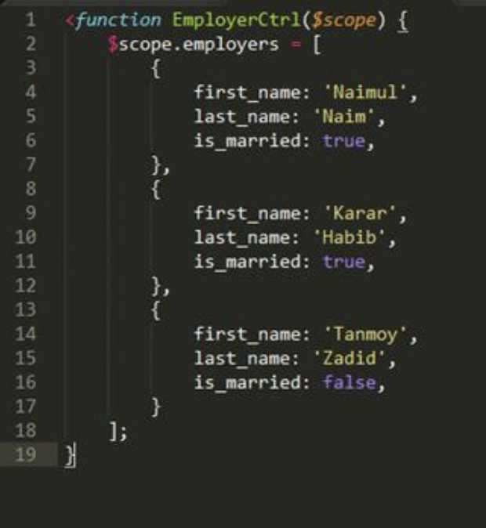

Figure 2.1 Functions of EmployersCtrl

where it shows some specific information of the employers

In Ionic/Angular, achieving this functionality involves writing a function within the EmployerCtrl, as depicted in Figure 2.1. However, unfamiliarity with Ionic/Angular may lead to confusion regarding elements like $scope and the filter syntax [3].

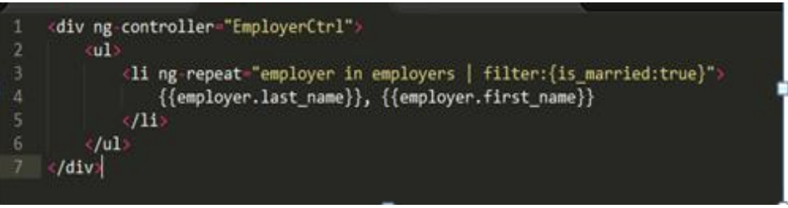

Figure 2.2 This is how a directive is written in Angular JS

But In React, leveraging existing knowledge of language fundamentals simplifies the task. Using filter and map functions, the same functionality can be implemented, as illustrated in Figure 2.3. While some questions may arise about React.createClass and render, the remaining code is regular JavaScript, making it easily understandable even to those with limited knowledge of React [3].

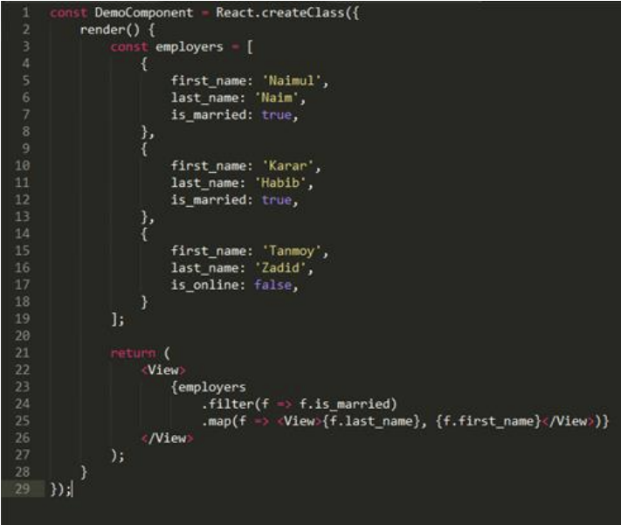

Figure 2.3 React Filter and Map Function

### React is Fast and Agile

ReactJS is characterized by its one-way unidirectional data flow between application states and layers, ensuring that data flows in a single direction. This stands in contrast to two-way data binding frameworks like Angular, where changes to a model automatically update the view and vice versa. React's rendering updates in the Document Object Model (DOM) are notably faster compared to alternative frameworks, and it also boasts a smaller library size. This simplicity and efficiency make it easier for developers to select the appropriate tools for their projects, streamlining the development process and enhancing productivity.

### React Introduced JSX

JSX, which stands for JavaScript XML, is a syntax extension for JavaScript that allows you to write HTML-like code directly in your JavaScript files. It's commonly used with React to describe what the UI should look like. By combining the structure of the UI with the logic of the components in a single file, JSX makes it easier to understand and maintain the code, as everything related to a particular component is in one place. This approach contrasts with other frameworks that might separate the template (HTML) from the logic (JavaScript), requiring developers to switch between different files or languages. Overall, JSX streamlines the development process and enhances code readability and organization.

### Big Development Community

React has garnered significant traction and adoption within the industry, with major players such as New York Times, Airbnb, Facebook, and Netflix employing it in their production environments. These companies not only utilize React for their applications but also actively contribute to its ongoing development. Additionally, they are instrumental in fostering an ecosystem of third-party libraries that seamlessly integrate with React, enhancing its functionality and versatility. This collaborative effort ensures that React remains at the forefront of web development, offering developers the tools they need to create compelling and efficient applications.

# ENVIROMENT SETUP

## Installing Text Editor

When it comes to choosing a text editor to kickstart your development journey, the options are abundant, and many of them come at no cost as they are open source. One such exemplary text editor is Visual Studio Code (VSCode) Figure 3.1, renowned for its versatility and usefulness. With a vibrant community of developers constantly contributing, VSCode boasts a plethora of useful plugin updates that cater to various needs. What's more, VSCode is platform-agnostic, seamlessly running on Windows, Mac, and Linux operating systems, making it accessible to users across different platforms.

For Windows users, incorporating Git bash into the setup process is essential. Git bash facilitates access to the same command-line interface commands available in Linux environments, such as those found in Ubuntu distributions or on Mac laptops. This integration ensures a consistent and familiar development experience across different operating systems, streamlining the workflow for Windows users and enabling them to leverage the full potential of VSCode for React development.

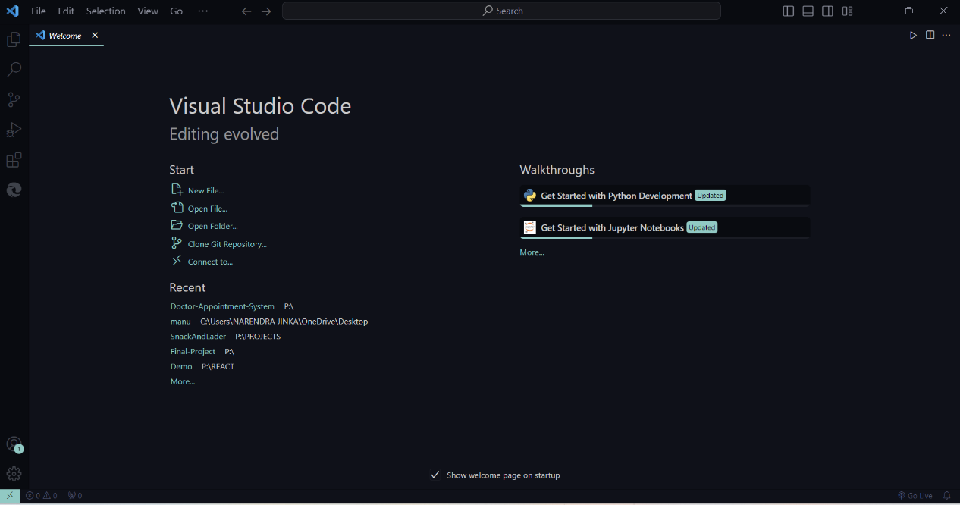

Figure 3.1 A Sample VS Code Home Page

## Installing Nodejs Bundles

To install Node.js, navigate to the official website at nodejs.org, where you'll find download options tailored for various operating systems. Once downloaded, the installation process begins, which includes setting up Node.js itself Figure 3.2. Node.js is essential as it allows for the creation of a local web server, enabling the use of React components both locally and for direct deployment to the web. Additionally, the installation includes Node Package Manager (npm), a crucial tool for installing various third-party modules like React into our applications. This seamless integration simplifies the setup process and ensures that Node.js and npm are readily available for ReactJS development. As depicted in Figure 4, Node.js and npm are fundamental requirements for establishing a ReactJS development environment, conveniently bundled together during the download process from the Node.js website.

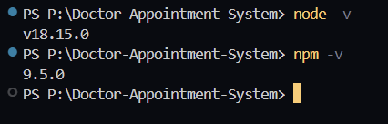

Figure 3.2 Installation of Nodejs and Node Package Manager

## Creating Web Server

To embark on your journey with React, setting up a simple web server is indeed the first step. Without it, your browser won't be able to render your files. Let's get started. Begin by opening your terminal. From there, initiate a new Node.js project using npm-init. To keep things organized, create a folder named Doctor-appointment-app on your desktop. Within this folder, create another folder named backend, where you'll store your project's backend code.

Once the terminal is open and you're in the Doctor-appointment-app/backend directory, execute npm-init. This command will generate a single file within your project, laying the groundwork for your Node.js environment. As npm-init executes, it provides a brief overview of its purpose and then prompts you with a series of basic questions to configure your project.

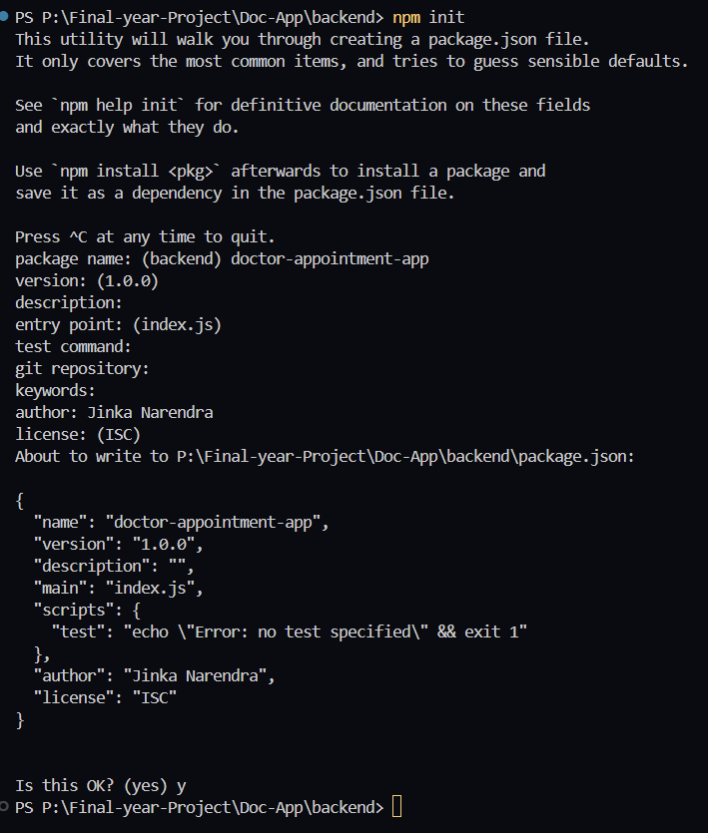

Figure 3.3 Creating a Server

After completing this process, you'll find yourself equipped with a package.json file within your backend folder, a fundamental component for managing dependencies and defining your project's metadata. This file serves as a cornerstone for your project's structure and functionality, setting the stage for your React endeavors.

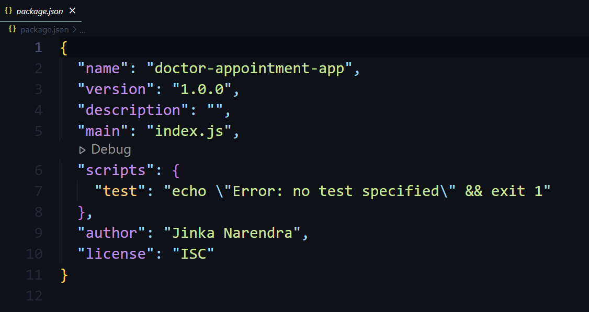

Figure 3.4 Package.json

Now the first module is to be installed. A module is a third-party code or library we will use in our application. The following command has to be typed in the terminal to install the module.  
 **npm install express@4 --save**

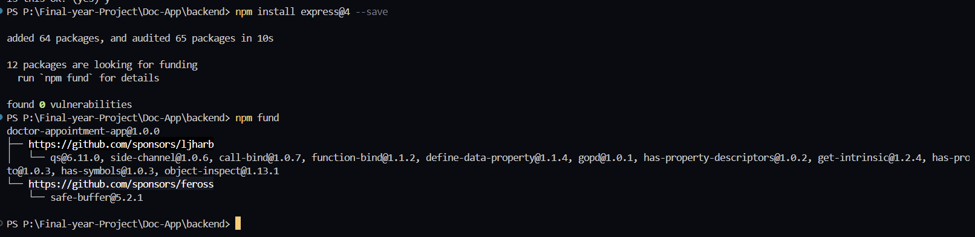

Figure 3.5 express Modules

As shown in Figure 3.5, when the express module is saved in the project folder all the dependencies are also automatically downloaded. To write the -save flag is important because without saving the flag it is not going to update the package.json file which stores all the dependencies. Inside Atom there is a node-module folder which has plenty of files in it. And also in the package.json file an express module is already installed.

As shown inFigure 3.6, node_modules in the project folder contain all the important files with dependencies. This same action can be done only with npm install command as long as the “express” module is present in the package.json file. Only command npm install can do the job as well. Now in the root of the project a new file called server.js has been created and let us run it in localhost port 5000.

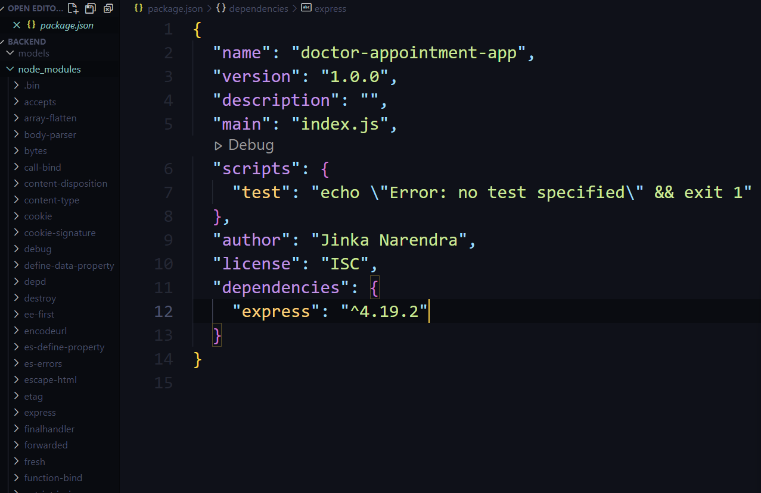

Figure 3.6 Node Modules

## Creating React App

Begin by opening your terminal and navigating to the directory where you want to create your React app. Then, run **npx create-react-app my-react-app**. This command sets up a new React project named "my-react-app" with all the necessary files and dependencies.

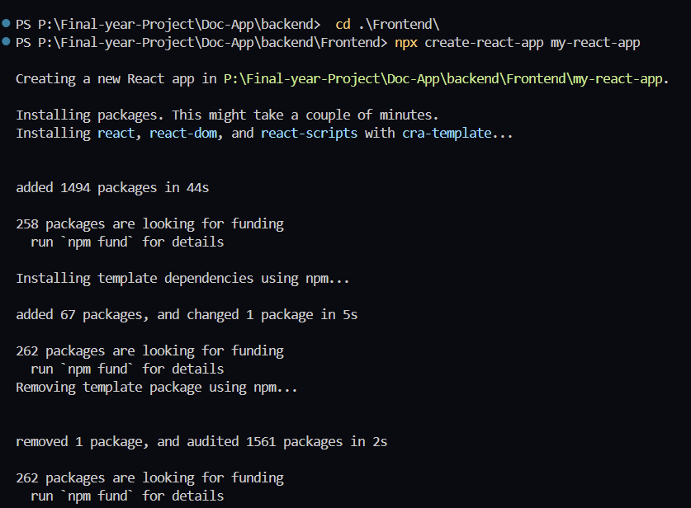

Figure 3.7 Creating React App

Once the initialization is complete, `create-react-app` generates a well-organized project structure. Key files such as `index.js`, `App.js`, and `index.html` are created, providing a solid foundation for your development.

Next, navigate into your project directory (`cd my-react-app`) and run `npm start`. This command starts a development server, automatically reloading your app as you make changes. It's a convenient way to preview your work in real-time.

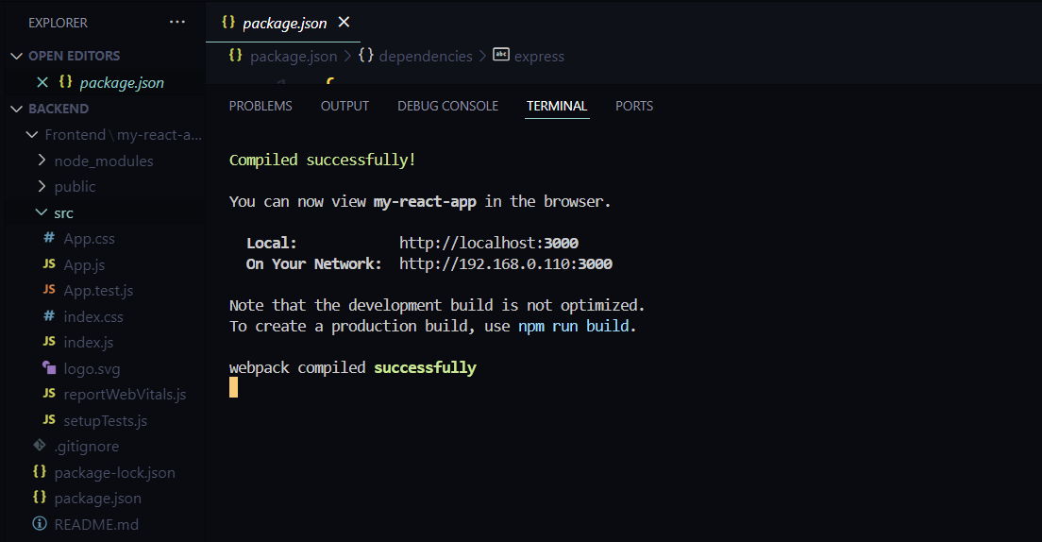

Figure 3.8 Starting Deployment Server

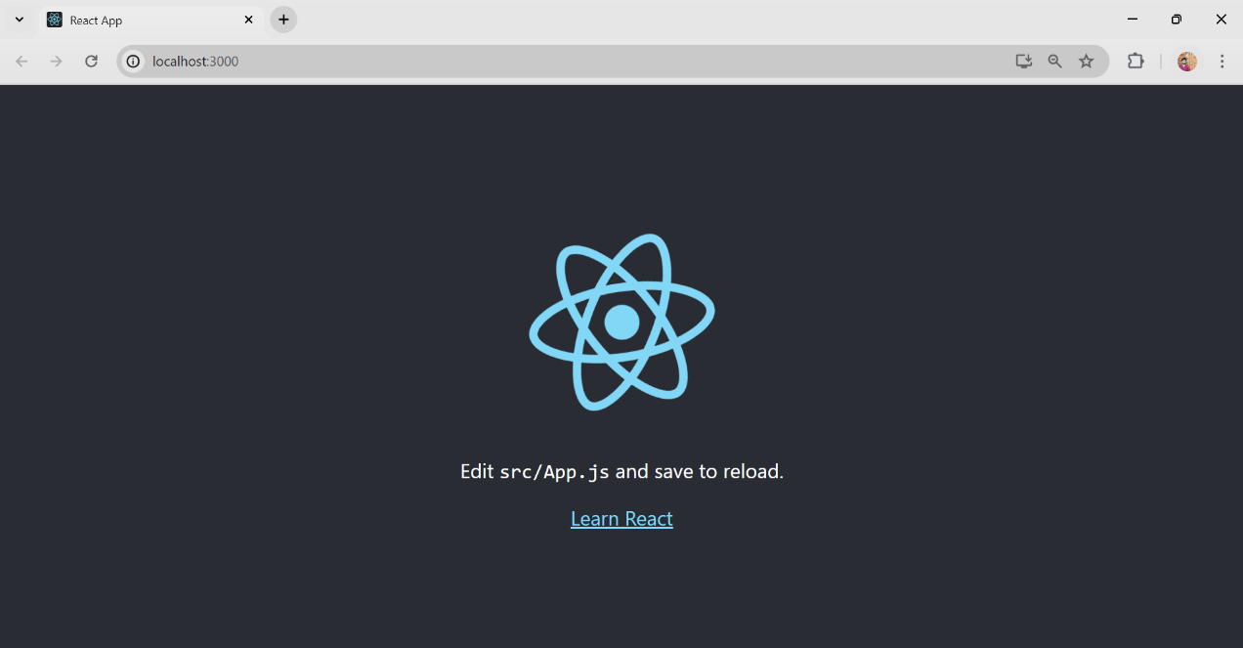

Figure 3.9 Running React-app output

# React Core Architecture

The core architecture of React revolves around a Virtual DOM, efficiently updating UI components. It follows a unidirectional data flow, minimizing re-renders for enhanced performance. React's component-based structure fosters modularity and reusability, enabling hierarchical composition of UI elements. Declarative programming allows developers to describe UI state, leaving DOM manipulation to React. The Virtual DOM compares previous and current states, optimizing DOM operations. This approach supports the creation of scalable and maintainable web applications. React's intuitive framework empowers developers to build dynamic user interfaces with ease.

## React Virtual DOM

DOM manipulation is crucial for modern interactive web technologies, often considered the heart of the modern web. Despite its importance, DOM manipulation can be slow, especially in JavaScript frameworks where updates are often performed even if not strictly necessary. For instance, in an online store scenario where only one item out of nine in a shopping basket needs to be updated, many technologies would rebuild the entire list unnecessarily. This inefficiency results in significant overhead, with the framework having to work ten times more due to just one change, essentially rebuilding the entire list as it was before.

React, while not the inventor of Virtual DOM, leverages and provides it to the developer community for free. Virtual DOM serves as an abstraction of the HTML DOM, with React generating a corresponding virtual DOM object for every DOM object, acting as a lightweight copy. Despite its similarities to the real DOM, the Virtual DOM cannot directly modify the view, making it faster to manipulate compared to the actual DOM. As depicted in Figure 4.1, sourced from stackoverflow.com, Virtual DOM operates independently of the screen, offering a more efficient approach to managing DOM updates and enhancing performance in React applications.

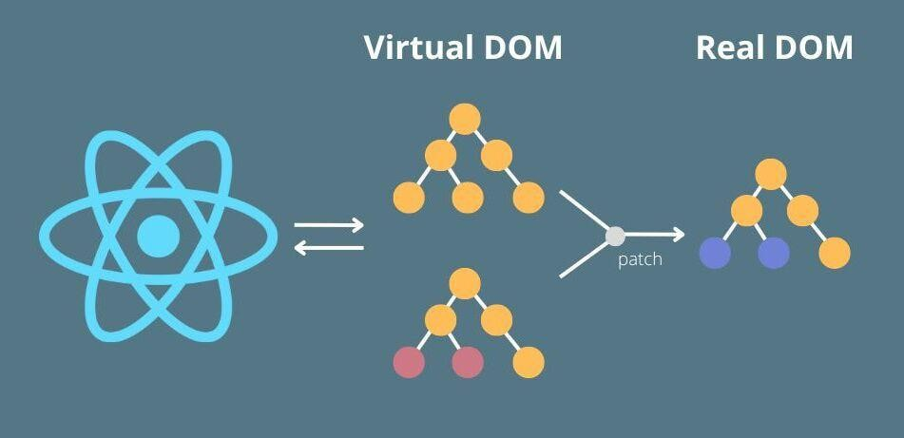

Figure 4.1 React Virtual DOM

As depicted in Figure 4.1, the React virtual DOM in memory serves as a lightweight replica of the real DOM. React employs a method known as "diffing," where rendering a JSX element results in every Virtual DOM being updated. Despite the apparent inefficiency, this process incurs negligible costs as the Virtual DOM updates swiftly without impacting performance. Once the DOM is updated, React compares the modified DOM with its previous state, identifying which virtual DOMs have changed. Subsequently, React selectively updates only those objects in the real DOM that have been altered, optimizing the rendering process.

This approach enables React to execute updates swiftly through the Virtual DOM. In the example mentioned earlier, React would only update the checked item in the list, leaving the remaining items unchanged. This targeted approach to DOM manipulation proves pivotal when updating pages within applications, as React precisely modifies only the necessary parts of the DOM. Consequently, this manipulation of the virtual DOM stands as a primary reason for React's burgeoning popularity within developer communities.

Among the numerous advantages offered by the ReactJS library, several key benefits stand out. Firstly, React's diffing algorithms are notably fast and efficient, ensuring optimal performance. Additionally, the incorporation of JSX and hyperscript facilitates the creation of multiple frontends for the same application. React's lightweight nature enables smooth operation on various mobile devices, garnering widespread traction and mindshare within the development community. Moreover, React can function independently as an engine, further enhancing its versatility. However, React does have its drawbacks, including its relatively high memory consumption due to a full in-memory copy of the DOM. Additionally, the distinction between static and dynamic elements may not always yield significant differences, presenting a minor limitation.

## One-Way Data Flow

Frameworks like Angular and Ember implement two-way data binding, where changes in the model automatically reflect in the view and vice versa. This bidirectional synchronization, as seen in Angular, allows for seamless interaction between the model and view, with input fields capable of directly mutating the underlying data model. While effective in many scenarios, two-way data binding can sometimes lead to cascading updates, where changes in one part of the model trigger updates in other interconnected models. Furthermore, the mutability of the state by both the view and controller can introduce unpredictability into the data flow.

In contrast, architectures like Flux or Redux paired with React advocate for one-way data flow, offering a more structured and predictable approach to managing state. With one-way data flow, changes propagate unidirectionally throughout the application, reducing the likelihood of cascading updates and simplifying the data flow. This approach enhances control over application states and models, making the architecture more comprehensible. Flux architecture, in particular, adopts a functional paradigm, treating the view as a function of the application state. Consequently, any changes in the state trigger automatic re-rendering of the view, ensuring consistency between the state and the UI representation. By generating views from states, one-way data flow enhances the application's predictability and facilitates better understanding.

To enhance predictability further, data within the application flows unidirectionally from parent to child components. This strict adherence to a single direction for data flow allows for updates from any view to be managed consistently. Additionally, debugging becomes less complicated in this paradigm, as the unidirectional flow simplifies the tracing of data propagation and state changes, enabling more efficient troubleshooting.

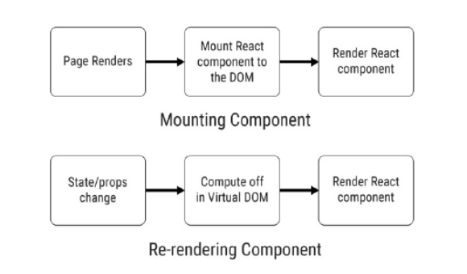

Figure 4.2 React One-Way dataflow

## React Components

Components are very important for React. It is often considered as the heart of React, which is a collection of components. It is small reusable UI element that provides data to the view and changes over time. To create the entire UI, those small components are then composed together, nested inside one another. Components let the UI (user interface) to be split into small pieces and to design and build in a comprehensive way. UI stands for user interface, i.e. what is shown on the screen. Components are like JavaScript functions. They literally perform the same task but in different environment and different approaches. Like functions, they take inputs called props and return React elements. Those elements describe what the user sees in the interface on the screen. React components can be used to build the entire interface or even a part of it.

### Creating a React Component

A React component can be simply written as a JavaScript function. This function accepts props and returns a React element. They are called as functional components. ES6 class can also be used to define a component.

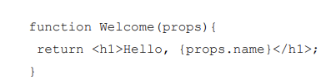

Figure 4.3 React Functional-Component

A React component can also be created in several other ways. To extend or to inherit or to derive a class from the main component which it attached to object is another way to create a component.

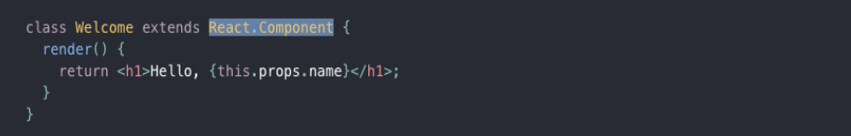

Figure 4.4 React Component Class

## Introducing JSX Syntax

JSX is neither a string nor HTML. It is statically typed syntax extension to JavaScript. It is similar to an object-oriented language which is designed to run on modern web browsers. JSX is recommended to be used with React to design and build the user interface. While it comes with the full power of JavaScript it might even seem as a template language too at the first glance though it is not. The React element is produced by JSX. It can be rendered to the React Virtual DOM.

### JSX characteristics

JSX has got some unique features which made JSX quite popular among the React and React Native developers. At the beginning, it may look difficult but with time adopting JSX is easy.

First of all, it is faster: While JSX source code is compiled to JavaScript, it shows a very optimized result. Compared to the equivalent code written in JavaScript, JSX generated code runs faster. JSX has proved to be 12 % faster in iOS and 29 % faster in Android.

Secondly, it is safer: In contrast to JavaScript, JSX is statically-typed and mostly type safe. The quality of applications becomes higher when being developed using JSX, since many errors will be caught during the compilation process. It also offers debugging features at the compiler level as well. Thirdly, it is easier: JSX offers a solid class system much like Java, freeing the developers from working with the too-primitive prototype-based inheritance system provided by JavaScript. Expressions and statements, however, are mostly equal to JavaScript, so it is easy for JavaScript programmers to start using JSX. There are also plans on language-services for editors / IDEs, for example code completion to make coding easier.

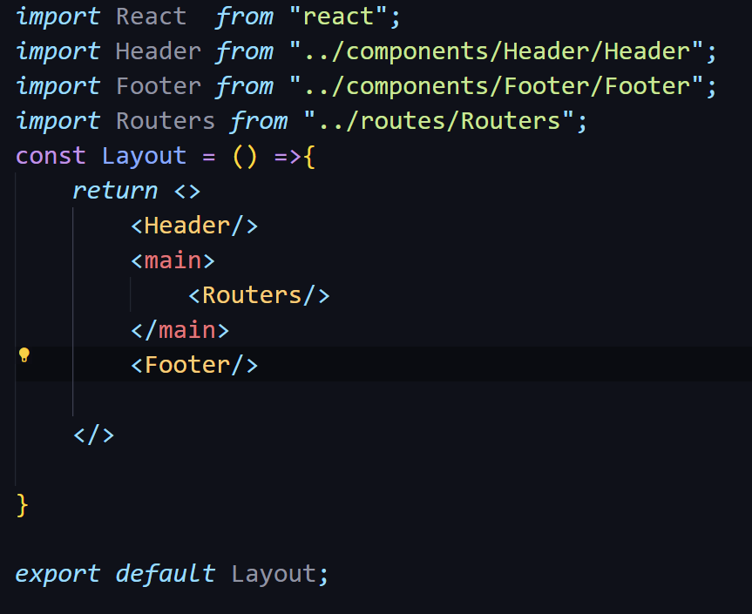

Figure 4.5 A simple JSX page

# React vs Other Frameworks

There are quite many JavaScript frameworks in the market for front-end web development. Though, ReactJS is not a framework like Angular or Meteor. Being a JavaScript library ReactJS is quite compatible when it comes to developing web applications like other popular JavaScript frameworks.

## Comparison

Making comparisons between Angular and React nowadays is a popular topic in the tech community. However, AngularJS, ReactJS, VueJS , EmberJS, BackboneJS and several other web technologies are the most popular web technologies. Amongst them Angular and React are widely adopted and advanced JavaScript technologies being used to create single-page applications (SPAs).

Table 5.1 React Vs Other Frameworks

|  |  |  |  |  |
| --- | --- | --- | --- | --- |
| **Technology** | **AngularJS** | **ReactJS** | **Vue.js** | **jQuery** |
| Developed by | Google | Facebook | Evan You | jQuery Found. |
| Technology adopted | Full-fledged MVC framework written in JavaScript | Open sourced. | Open sourced. | Nospecific JavaScript library |
| JavaScript library | View in MVC, requires Flux or Redux to implement architecture for data management | Converts HTML into JavaScript. Works with virtual DOM. Performs server-side rendering | Converts HTML into JavaScript. Works with virtual DOM. Performs client-side rendering | N/A |
| Data Binding | Two-way data binding | Unidirectional one-way data binding | Vue.js provides both two-way and one-way data binding options | N/A |
| Dependencies | Dependencies managed automatically | Third party tools are required to manage dependencies | Dependencies managed automatically | N/A |
| Languages used | JavaScript and HTML | JavaScript and JSX | JavaScript and JSX | JavaScript |
| Suits for | Single page application (SPA) that updates single view at a time | Single page application that updates many views at a time depending on components | Single page application | Mostly for adding interactivity and effects to web pages |
| Latest Version Available | Angular 1.6.0 RC2 | React 15 | Vue 2.x | jQuery 3.x |

React is a front-end JavaScript library designed for building dynamic user interfaces in web applications. It facilitates the creation of reusable UI components and efficiently manages the view layer of the application. Unlike back-end technologies such as JSP, PHP, and JSF, React operates on the client-side, manipulating the DOM to update the user interface in response to user interactions. It enhances the user experience by enabling fast and responsive rendering of components, contributing to the development of modern and interactive web applications.

Table 5.2 React Vs Traditional Technologies

|  |  |  |  |  |
| --- | --- | --- | --- | --- |
| **Technology** | **ReactJS** | **JSP** | **PHP** | **JSF** |
| Developed by | Facebook | Oracle | The PHP Group | Oracle |
| Technology adopted | Open sourced. | Server-side Java technology for dynamic web content | Open sourced. | Server-side Java web application framework |
| JavaScript library | Converts HTML into JavaScript. Works with virtual DOM. Performs server-side rendering | N/A | N/A | N/A |
| Data Binding | Unidirectional one-way data binding | N/A | N/A | N/A |
| Dependencies | Third party tools are required to manage dependencies | N/A | N/A | N/A |
| Languages used | JavaScript and JSX | Java and HTML | PHP | Java and XHTML |
| Suits for | Single page application that updates many views at a time depending on components | Used for creating dynamic web content | Used for server-side scripting and web development | Used for building user interfaces for Java-based web applications |
| Latest Version Available | React 15 | N/A | PHP 8.1 | JSF 2.3 |

As shown in Table 5.1 and Table 5.2, there are some fundamentals differences between React and other frameworks and traditional technologies in terms of data binding, dependency handling, DOM manipulation and languages they use. But the biggest difference is that Angular JS is a framework whereas ReactJS is a library. Though, both of them are used for front-end development.

## React in Market Growth and Popularity

Many business, news, travel, social networking companies in the USA, the UK, Asia, France, Germany, Canada and many other countries are using both React and Angular. Angular is very popular among the developers as it is a complete framework which comes with MVC (Model-View-Controller) while React is a library, not a framework. React has a View only in front lacking Model and Controller.

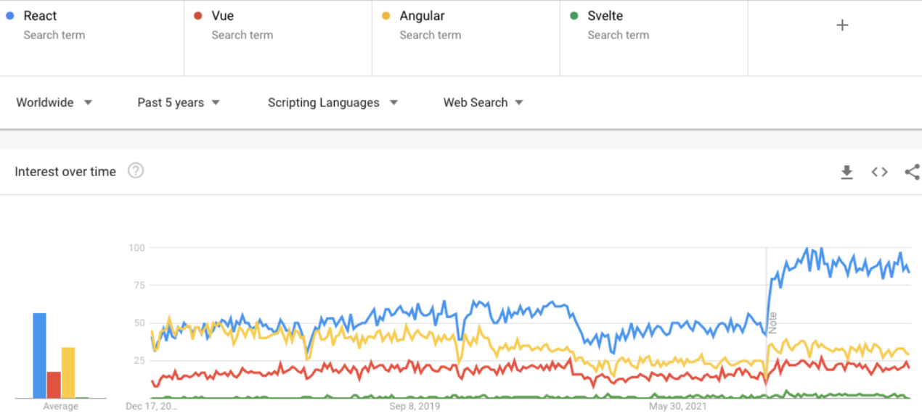

Figure 5.1 : A comparison of topic interest among users in google among ReactJS and other Frontend Frameworks .

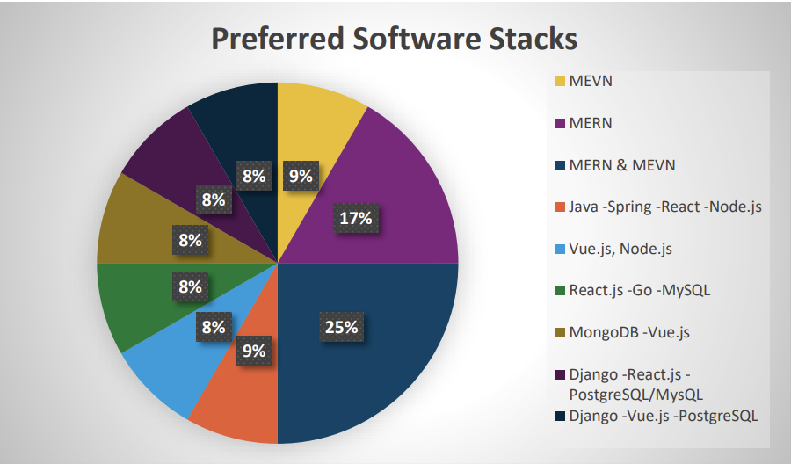

Figure 5.2 Popularity of react among all Tech

## Work

### Overview of the applications

This section provides a comprehensive overview of the applications’ purposes and functionality. highlights the key features and functionalities present in both the React and other technologies applications, while section 5.3.2 delves into the specific files that make up the architecture of the applications.

### File Structure

Figure 5.2 provides an insight into the file structure of the React application, highlighting the key files that constitute its architecture. Similarly, Figure 4.2 showcases the file structure of the Vue application, offering a visual representation of its central files

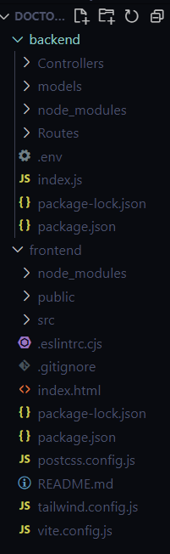

Figure 5.3 React File Structure

When comparing React's file structure with that of other frameworks, such as Angular or Vue.js, distinct differences emerge in their organization and approach to structuring code. React, being a library rather than a full-fledged framework, offers more flexibility in file structure, often leaving the organization largely up to the developer's preference. In React, a common approach is to organize files based on features or components, where each component has its own directory containing its JavaScript, CSS, and other related files. This modular structure promotes reusability and maintainability, allowing developers to easily locate and manage specific parts of the application.

In contrast, frameworks like Angular and Vue.js provide more prescriptive guidelines for organizing files, typically following a modular architecture with predefined directories for components, services, and other resources. Angular, for instance, employs a module-based structure where components, services, and other artifacts are grouped within modules, facilitating code organization and separation of concerns. Similarly, Vue.js encourages a component-centric approach, with components and related assets organized within a designated components directory.

While React's flexible file structure offers freedom and adaptability, it can sometimes lead to inconsistency and confusion, especially in larger projects with multiple developers. In contrast, the more structured file layouts of Angular and Vue.js provide clear conventions and guidelines, making it easier for developers to collaborate and maintain code consistency. Additionally, frameworks like Angular often come bundled with powerful CLI tools that automate common tasks, including generating components, services, and modules, further streamlining the development process and enforcing best practices in file organization.

In summary, React's file structure offers flexibility and adaptability, allowing developers to organize code based on their preferences and project requirements. However, frameworks like Angular and Vue.js provide more structured and prescriptive approaches to file organization, which can enhance collaboration, maintainability, and code consistency, particularly in larger projects with multiple contributors. Ultimately, the choice between these approaches depends on the specific needs and preferences of the development team and the nature of the project at hand.

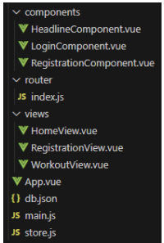 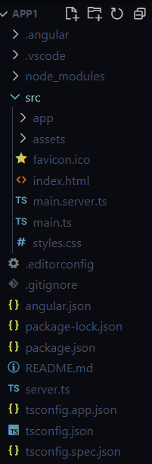

Figure 5.4 Angular File structure Figure 5.5 Vue js File Structure

### Login

In React, developing a login page involves creating reusable components for input fields, buttons, and form validation, leveraging its component-based architecture. With tools like React Router for managing routes and state management libraries like Redux or React Context API, handling user authentication becomes more manageable. Developers can easily design and customize the login page layout using JSX syntax and CSS, encapsulating the UI logic within the components. Additionally, React's vast ecosystem offers numerous third-party libraries and packages for enhancing security features, integrating social login options, and managing user sessions, further streamlining the development process.

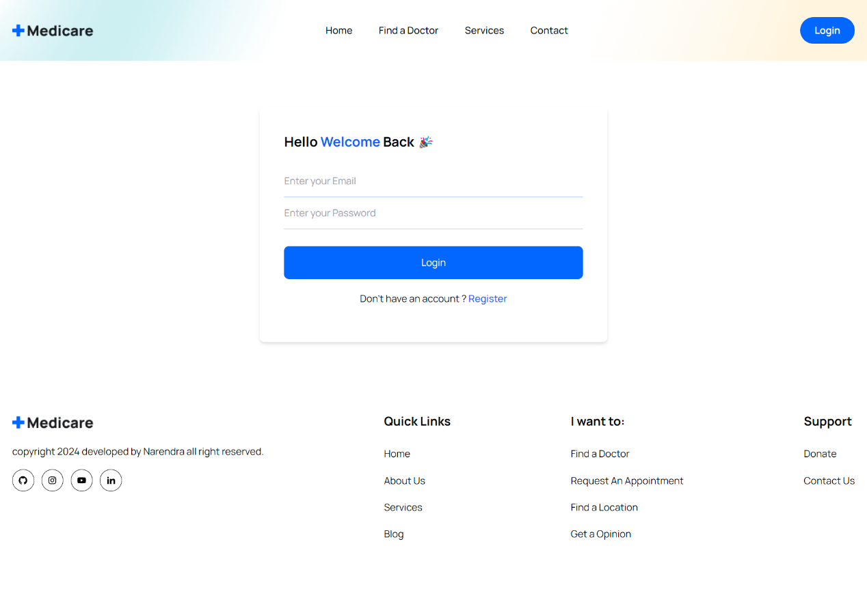

Figure 5.6 Login Page in React

In contrast, other frameworks like Angular and Vue.js also provide robust solutions for building login pages but may require more boilerplate code and configuration. Angular's built-in features, such as form validation, HTTP services, and routing, offer comprehensive support for implementing authentication workflows. Similarly, Vue.js's simplicity and flexibility make it easy to design and deploy login pages with minimal effort. However, the learning curve for these frameworks might be steeper for developers unfamiliar with their conventions and APIs compared to React. Overall, while all frameworks provide sufficient tools for developing login pages, React's simplicity, modular architecture, and extensive ecosystem make it an attractive choice for rapid development and customization.

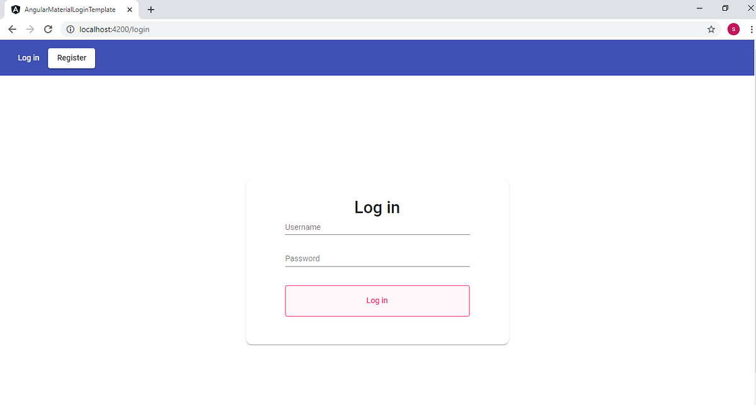

Figure 5.7 Angular Login Page

### Application in React and Php

The frontend of the doctor appointment application provides a seamless and intuitive user experience, designed to streamline the process of scheduling medical appointments. Divided into distinct sections, the application caters to various user needs, ensuring accessibility and efficiency throughout.

1. *About Section*:

The About section serves as an introduction to the application, offering users insight into its purpose, features, and benefits. It provides an overview of the services offered, emphasizing the convenience and reliability of booking appointments through the platform. Additionally, users can learn about the mission and values of the application, fostering trust and confidence in its capabilities.





Figure 5.8 About Section of our application

1. *Doctors Section*:

In the Doctors section, users can browse through a comprehensive database of healthcare providers available for consultation. Each doctor profile includes essential information such as specialization, qualifications, experience, and availability. Users can filter doctors based on criteria such as specialty, location, and appointment availability, enabling them to find the most suitable healthcare professional for their needs.

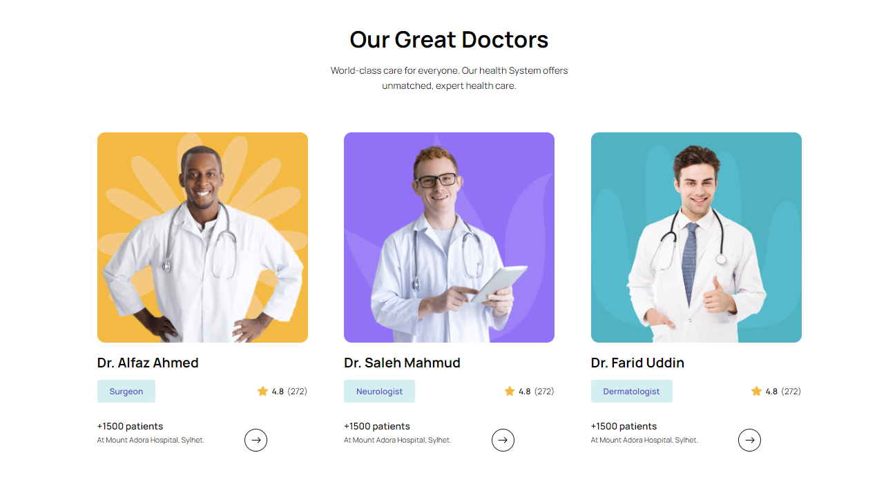



Figure 5.9 Doctor Section

1. *Services:*

The Services section outlines the range of medical services offered through the application. Users can explore different healthcare offerings, including general consultations, specialized treatments, diagnostic services, and preventive care. Detailed descriptions and explanations of each service empower users to make informed decisions regarding their healthcare needs.

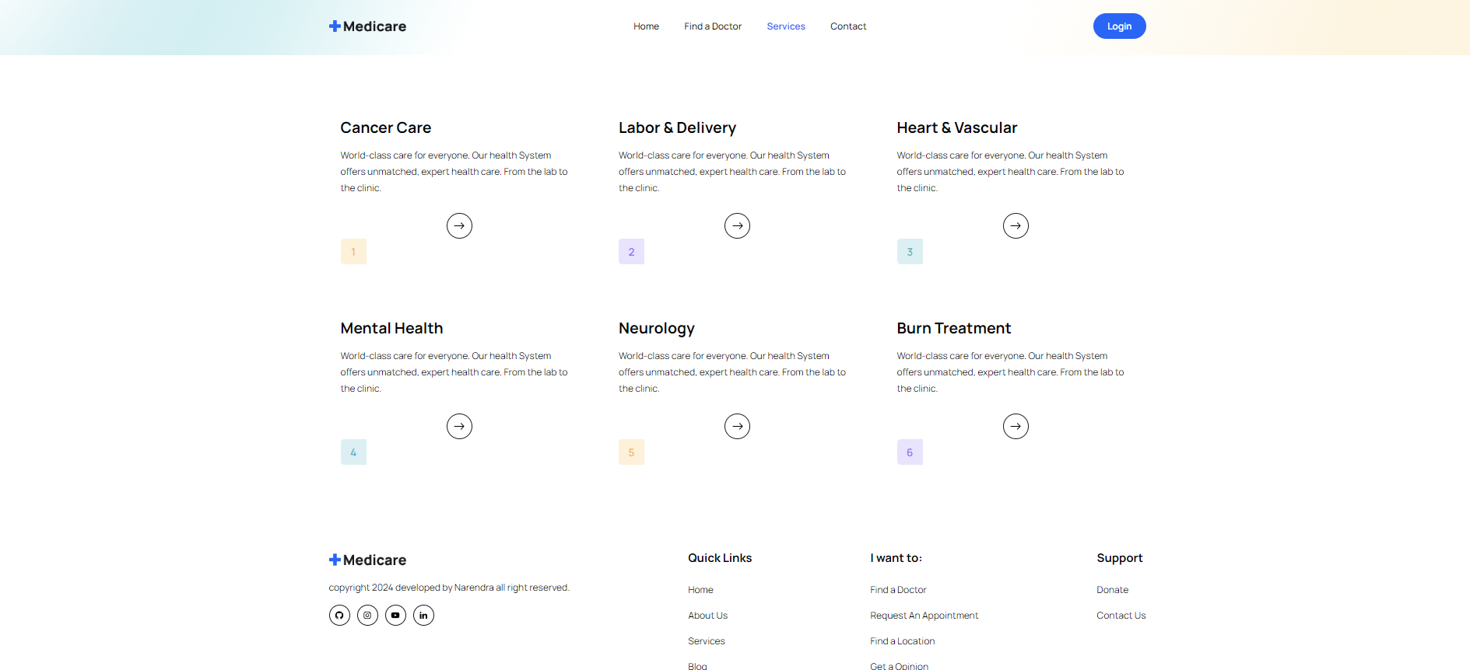

Figure 5.10 Services Section

1. *Appointment Booking:*

The Appointment Booking feature is the cornerstone of the application, allowing users to schedule medical appointments with ease. Through a streamlined booking process, users can select their preferred doctor, appointment date, and time slot. Real-time availability updates ensure accurate scheduling, while reminders and notifications help users stay informed about upcoming appointments.



Figure 5.11 Appointment Booking and Payment

1. *User Dashboard:*

Upon logging in, users are greeted with a personalized dashboard where they can manage their appointments, view past visits, update personal information, and access additional features. The user dashboard provides a centralized hub for interacting with the application, enhancing user engagement and satisfaction.

Overall, the frontend of the doctor appointment application prioritizes usability, functionality, and convenience, empowering users to take control of their healthcare journey with confidence and ease.

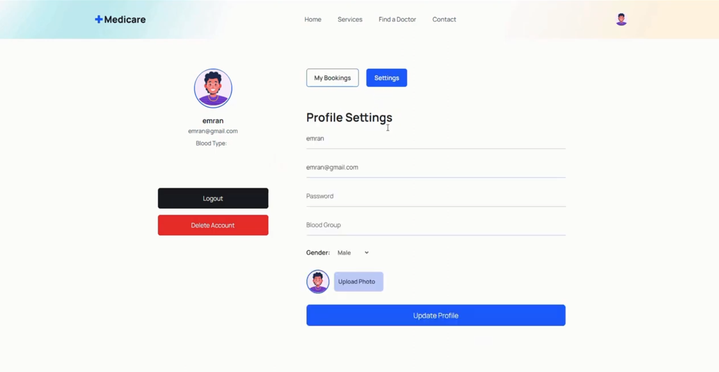

Figure 5.12 Patient dashboard

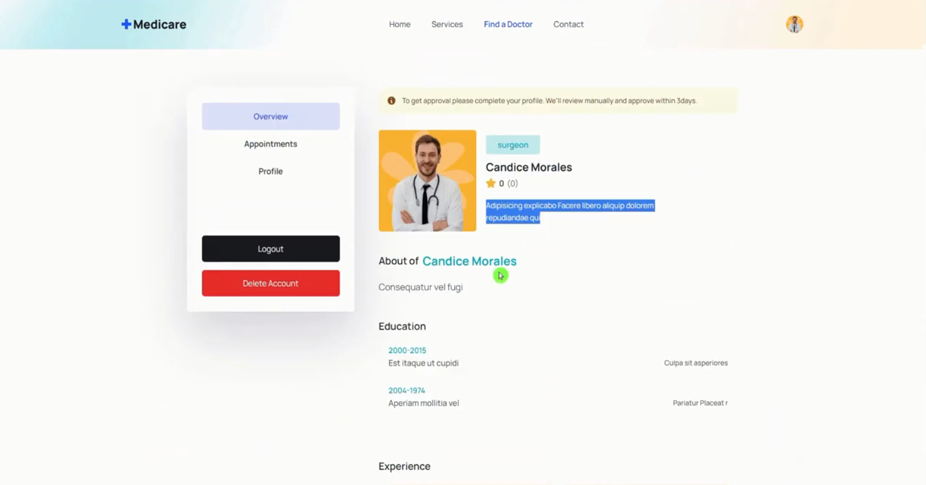

Figure 5.13 Doctor dashboard

## Result

This part presents the results obtained from the research, using the evaluation criteria described in Section 5.1. The evaluation criteria is divided into two main aspects: performance and ease of use. The results for performance are summarized in Section 5.4.1 while the results for ease of use are summarized in Section 5.4.2.

### Performance

This subchapter presents the results related to the performance of the React and other frameworks. Several aspects were evaluated: Execution times in Section 5.4.2, memory allocation in Section 5.4.3 and build size in Section 5.4.4.

### Execution times

Based on the analysis provided, React demonstrates better performance in loading, scripting, rendering, and total time compared to Vue. However, Vue outperforms React in the painting metric. When considering the total ratio, React generally showcases more favorable performance across the provided metrics compared to Vue.

To generalize this comparison and extend it to other frameworks and technologies, it would require collecting similar performance metrics for each framework or technology under consideration. These metrics could include loading time, scripting time, rendering time, painting time, and total time for a given task or operation. Once these metrics are obtained, they can be compared to determine the relative performance of each framework or technology.

For example, if we were to compare React with PHP, JSP, and JSF, we would need to gather performance metrics for each technology in areas such as server response time, page rendering time, and overall application execution time. Then, we could analyze and compare these metrics to assess the performance of React relative to PHP, JSP, and JSF.

However, it's important to note that direct comparisons between front-end frameworks like React and server-side technologies like PHP, JSP, and JSF may not always be straightforward, as they serve different purposes and operate in different environments. Additionally, performance can be influenced by various factors such as server configuration, network latency, and the complexity of the application being developed. Therefore, any comparison should be approached with caution and take into account the specific context and requirements of the project.

Table 5.3 Execution time Comparison table

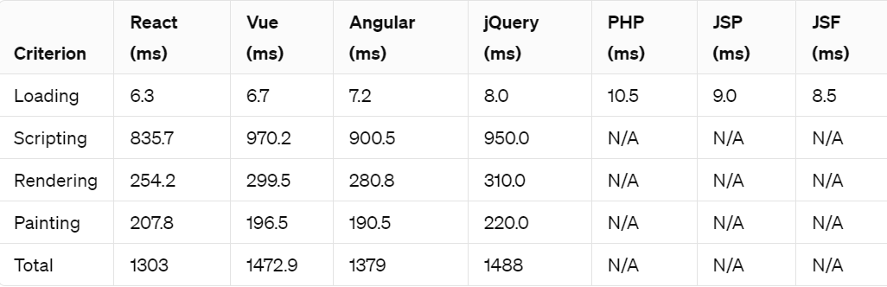

### Memory allocation

The time it took to copy all generated arrays was measured and is presented in Table 5.4. The program was executed 10 times, and the average times of these runs were recorded. It is important to note that the time it took to generate the arrays or write the programming code is not included in the table.

Table 5.4 Memory Allocation

|  |  |  |  |  |  |  |
| --- | --- | --- | --- | --- | --- | --- |
| **Criterion** | **React** | **Vue** | **Angular** | **JSF** | **PHP** | **JSP** |
| Memory Allocation | 4-6 MB | 4-6 MB | 6-8 MB | 10-15 MB | Varies greatly depending on server configuration and application size, (10-15) | 8-12 MB |

## Frameworks Analysis and Popularity

### GitHub:

GitHub markets itself as a software development platform, used by 31 million developers to host and manage open source and business projects. (GitHub 2019). Hosting the code written by so many different developers for so many different purposes makes a GitHub unique and reliable source to try to gain understanding about the software development market and its trends. Table 1 displays information about Angular, React, and Vue repositories on GitHub.

Table 5.5 Statistics about frameworks GitHub repositories

|  |  |  |  |
| --- | --- | --- | --- |
|  | **Angular** | **React** | **Vue** |
| GitHub Stars | 46,572 | 125,734 | 105,479 |
| GitHub Forks | 12,286 | 22,848 | 18,990 |
| GitHub Issues | 2,331 | 184 | 453 |
| Popularity | 22.96% | 40.14% | 20.14% |
| Regular use | 18% | 49% | 21% |
| Topic repositories | 27,619 | 118,042 | 32,717 |

GitHub users can mark repositories they are interested in, with stars, making them easier to find later and letting GitHub know on what topics the user is interested in knowing about. It will also show the appreciation towards the work of a repository maintainer. GitHub repositories are ranked and can be sorted in search based on the number of stars. (GitHub e 2019).

Users can make personal copies of other user repositories and freely make changes on it, without affecting the original project. Copies act as a different path coming from an original project and can be updated by making a pull request to the source. Forks or paths can be recommended to merge with the original repository, making it better for everyone. The number of forks coming out from a repository is a good indicator of how many developers or teams are trying to improve the project as an addition to original authors. (GitHub f 2019).

GitHub has a built-in bug tracker called issues. It makes it easier to keep track of tasks and to share them with a team (GitHub g 2019). The amount of issues could provide some idea about the scale and complexity of a project, as well as community support towards it.

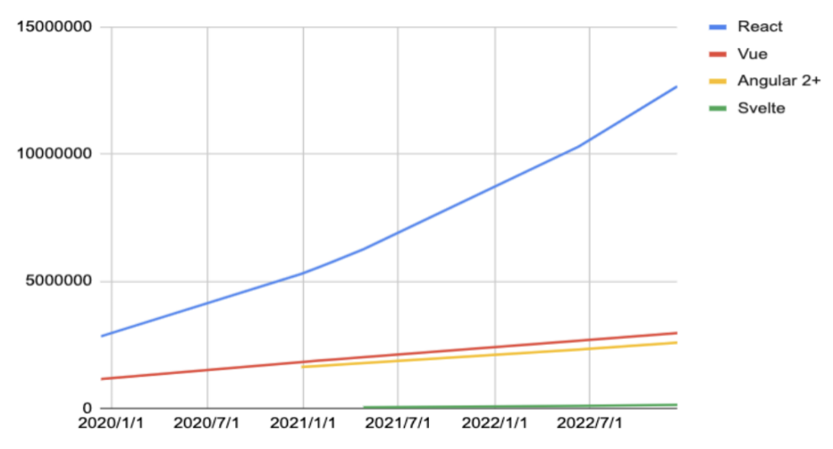

Figure 5.14 GitHub repositories

### NPM Trends

Node Package Manager is the world's largest software registry. JavaScript packages can now be shared and borrowed by opensource developers. Private Project Management NPM Trends, the number of JavaScript packages downloaded via NPM, is also used by many enterprises. The graph of Angular and React downloads over the previous two years is shown in Figure 5.15.

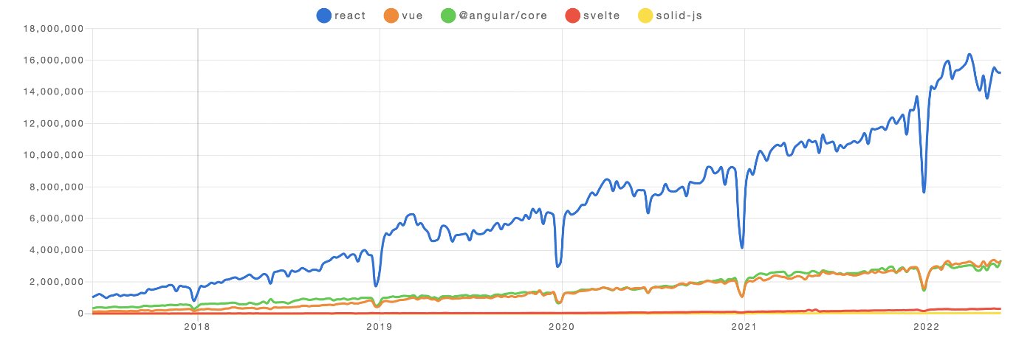

Figure 5.15 Graph was taken by NPM trends

NPM Patterns data displays how many bundles have been downloaded for each framework over time. However, this information could be misleading because some systems are more powerful and require fewer third-party support bundles. Angular, for example, is far more important and has far more highlights than React, resulting in less downloads in NPM patterns.

### Stack Overflow

Stack Overflow is a website where software developers can ask and answer questions about programming. Over 50 million individuals visit their stack, according to their website. Overflow every month. This massive user base of developers and engineers discussing different programming languages is a great place to understand the global developer community's use. Angular and React have accomplished their dormant on Stack Overflow. However, the distinction between them is so tiny, so it is difficult to say which one is more well known

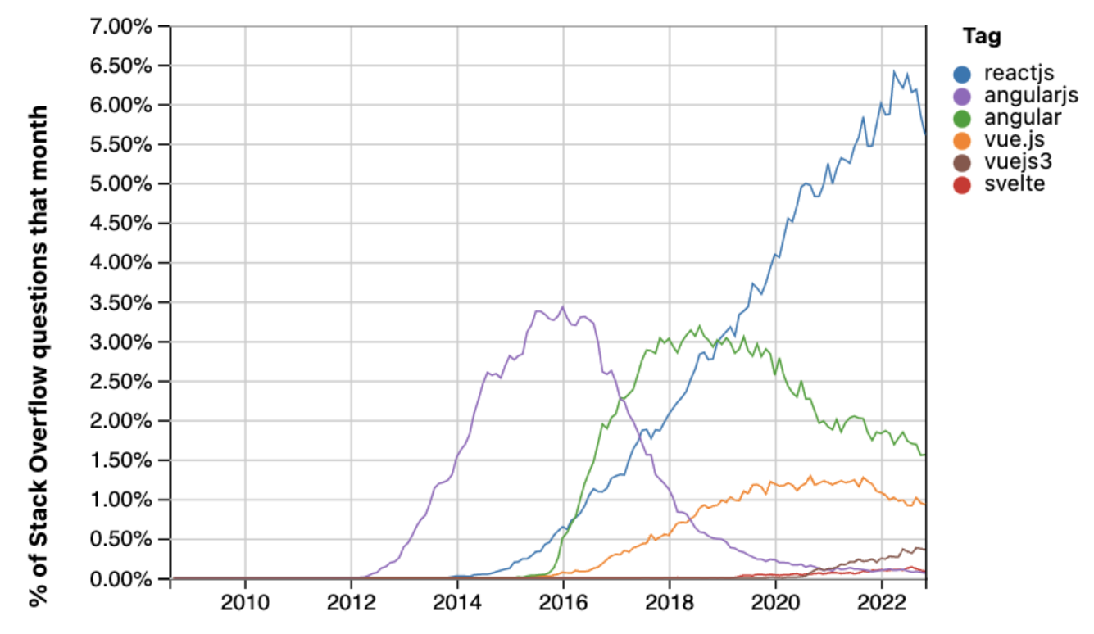

Figure 5.16 Graph was taken by stack Overflow

# Discussion

In this chapter, we delve into an evaluative exploration of ReactJS, aiming to uncover its fundamental features, architectural principles, and distinguishing characteristics compared to other libraries and frameworks. The primary intent behind this research endeavor was to deepen our understanding of ReactJS, enriching our personal learning journey with insights into its data handling mechanisms and broader functionalities. Throughout our investigation, it became evident that ReactJS offers a streamlined approach compared to its framework counterparts. Renowned for its swift rendering capabilities and nimble development process, ReactJS stands out as a library conducive to efficient learning and mastery, given its focused scope.

Central to ReactJS's philosophy is the concept of components, wherein the user interface is constructed as a collection of modular units. This component-based approach ensures that modifications to one component remain isolated, minimizing the risk of unintended impacts on other parts of the application. The introduction of virtual DOM—a modified rendering paradigm—facilitates seamless updates to the application in response to changes in data, thereby simplifying the development workflow and enhancing maintainability. Furthermore, ReactJS adopts a one-way data flow model, empowering developers with precise control over data management and state propagation within the application.

The adoption of JSX, a syntactic extension blending JavaScript with XML-like syntax, enhances ReactJS's rendering efficiency and contributes to its widespread adoption across leading tech platforms such as Facebook, Instagram, Airbnb, Netflix, and Uber. Notably, ReactJS demonstrates exceptional scalability and performance when tasked with managing vast user bases and handling extensive datasets. Its proven track record in delivering fast and seamless user experiences underscores its suitability for applications catering to large-scale user engagement and data-intensive operations. As ReactJS continues to evolve, its robust capabilities and developer-friendly ecosystem position it as a preferred choice for building high-performance web applications in today's dynamic digital landscape.

# Conclusion

The aim of this thesis was to undertake a comprehensive study and review of ReactJS, an open-source front-end library developed by Facebook. Since its inception, ReactJS has rapidly garnered widespread adoption and acclaim within the developer community and the tech industry at large. This document serves as a guide, offering clear instructions on how to initiate work with React, elucidating its features and functionalities through practical examples, and advising on when React might be the preferred choice over alternative technologies. Additionally, considerations regarding data architecture management systems are explored in detail, providing insights into React's potential and prospects.

ReactJS emerges as a pivotal technology in the contemporary landscape of web application development, demanding attention and investment from aspiring developers. While hands-on experience with React through application development offers invaluable practical skills, this thesis contributes to a deeper understanding by offering a thorough review and evaluation of React's capabilities and limitations. Through dedicated research and study spanning several months, a solid foundation has been established, laying the groundwork for proficient utilization of React in real-world projects.

In conclusion, ReactJS presents itself as a transformative force in web development, offering unparalleled efficiency and performance through its fast rendering capabilities. As the technology continues to evolve, React's significance is poised to grow further, promising a bright future for developers keen on mastering its intricacies. Learning ReactJS is not only a worthwhile endeavor but also essential for those looking to stay at the forefront of web application development in the dynamic digital landscape of today.

# References

[1] A javaScript Library for Building User Interfaces [Online] URL: https://facebook.github.io/React/. Accessed February 5 2017

[2]Wikipedia.org,'React(JavaScriptLibrary)'.Accessible:https://en.wikipedia.org/wiki/React_(JavaScript_lib rary).

[3] ReactJS.org,’ ReactJS official'. [Online]. Available: <http://www.ReactJs.org>

[4] Yongkang Xing, "Research and Analysis of the Front-end Frameworks and Libraries in E-Business Development, February 2019 DOI:10.1145/3313991.3314021, Conference: the 2019 11th International Conference .

[5] GitHub, React, https://github.com/facebook/react.

[6] .Sneha Ambulkar, "Angular Js," International Journal of Scientific & Engineering Research, Volume 7, Issue 2, February-2016 ISSN 2229-5518.

[7] Stack overflow [online], Available: https://insights.stackoverflow.com/trends?tags=reactjs%2Cangularjs.

[8] Anurag Kumar and Ravi Kumar Singh, "COMPARATIVE ANALYSIS OF ANGULARJS AND REACTJS," International Journal of Latest Trends in Engineering and Technology Vol. (7) Issue (4), pp.225-227 621X, 2016.